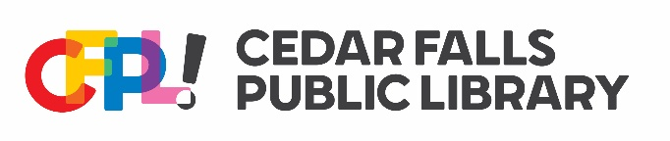
CFPL Strategic Plan: 2025-2030
In light of the prior five-year strategic plan, three general areas needing continued focus, improvements, and/or completion include:
- Continued emphasis on outreach and library visibility
  - Explore new avenues of marketing the library in the community
- Foster existing and expand to new community partnerships
- Continue to evaluate the overall space and the layout of the library
The following areas have been identified as newer initiatives that can be developed:
- Provide enriching educational opportunities and resources
  - Provide a variety of materials in collections that meet the needs and interests of our varied community.
  - Continue to refresh (weed and acquire new items) the Library of Things as space allows.
- Facilitate community connections through programs, services, and spaces
  - Use technology to improve the patron experience: meeting room reservations; digital calendar; suggest tech products for patrons to continue their explorations or increase their autonomy; advertise featured programs on the Koha receipts
- Act as a community hub for information and connections to community services
- Provide more access points for informational resources such as in the atrium and at more of the service desks

The following are CFPL patron groups, new and renewed, who should be the subject of specific programming and service focus:
- New residents and potential library users
- Underserved populations
  - Emphasize accessibility-friendliness
- Aging and shifting populations of users
  - Increase access to collections through satellite off-site collections
  - Increase programs for 18-30 year-olds
The following are programming areas that CFPL can reasonably grow or develop over the next five years:
- Arts and culture-related programs
  - Presentations by experts
  - High-interest, recorded programs to post on our YouTube channel
  - Programs and exhibits that allow patrons to showcase their own creative works
- Expand discourse-based programming
  - Panel discussions
  - Expert-led discussions
- Social-focused programming

Approved by the Library Board of Trustees 12/3/25

